# The Client: Tetris 3D

## Game Premise

In this session each group was given a scenario from this, another group within the class had to interview them and ask questions in order to find out about the scenario they received in order to develop a game for their ‘company’ based around this scenario.

The scenario my group worked with to develop a single-player game was to produce a physical based Tetris game for mobile devices that would need to be developed for a deadline within three months’ time and would be marketed for all genders with a age restriction of 12 years+ and would need to be developed in order to be available for Apple, Android and Microsoft platforms. The final concept my team came up with was to develop a version of Tetris, that the player would tackle from multiple sides using a 3D function. This would work well as the player could use a phone’s touch screen to flick through in order to view of the game from multiple different angles.

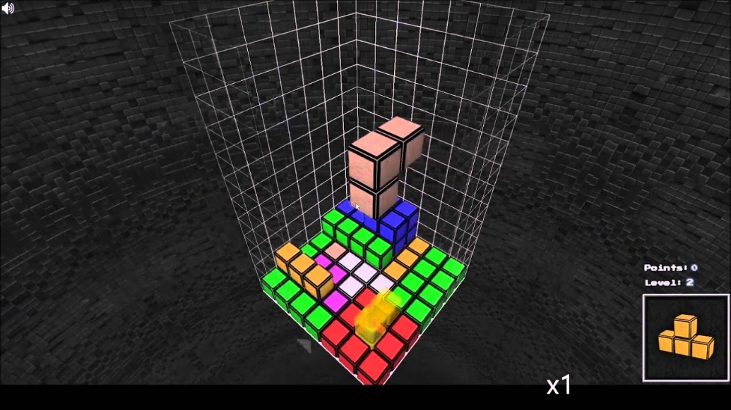

Fig 1) Initial concept design for Tetris 3D

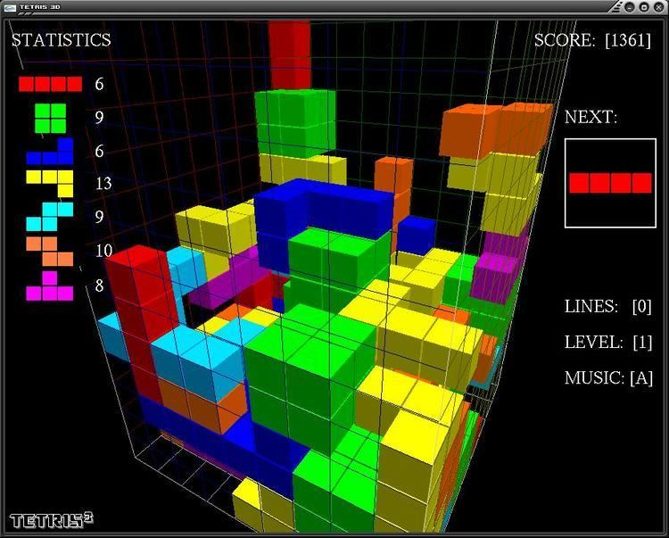

Fig 2) Second Initial Concept Design for Tetris 3D

## Material used to make the game

The game would be produced digitally using a software to develop mobile games e.g. Unity.

## Rules and Mechanics

* Rules apply as they would for a basic game of Tetris
* All pieces must fit together securely
* No gaps must be left between pieces
* Once shapes have aligned to make a solid block that line will disappear from the screen and the remaining lines and pieces will move down
* If pieces manage to reach the top of the screen on any of the screens on the 3D game, the player will lose

## How the game is played.

The game is played on a 3D layout. Different shaped pieces will cascade one at a time from the top of the screen (see Fig 3 for example pieces)

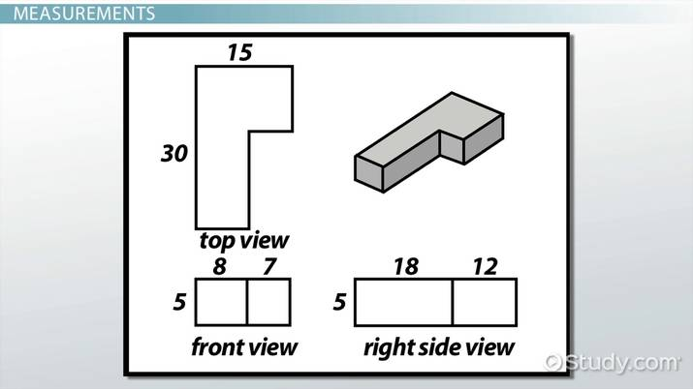

Fig 3) Example Pieces

Players can rotate these pieces any way to enable the pieces to slot together easily. The player will need to focus on making sure these pieces slot together in order to complete a line, once the line is complete it will disappear from the screen and all other lines and pieces will move down allowing the player to continue playing.

If the player manages to have one screen of the 4 screens completely full to the top with shapes the game is over and the player loses.

## ­Experience working in the team to problem solve.

In this session I believe my team worked cohesively together and were able to share our ideas well and communicate successfully. We were able to communicate well with our client team and use the information they gave us to develop a game concept we were proud of and thought fit the brief from our client team well.

## Team members.

Joshua Wye (Me)

Joshua Baker

Spas Spasov

463 Words without Fig headings.

## List of illustrations

Fig 1) Initial concept design for Tetris 3D

Fig 2) Second Initial Concept Design for Tetris 3D

Fig 3) Example Pieces